AIM: STUDY OF BASIC COMPUTER NETWORKING DEVICES
- UTP (Unshielded Twisted Pair) Cables:
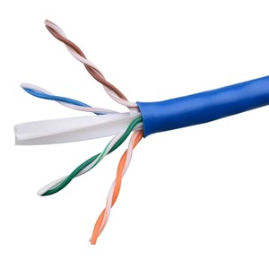
- Router:
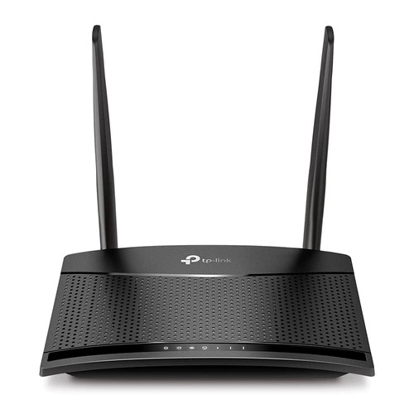

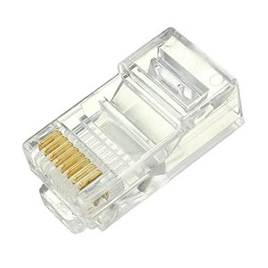
- RJ 45 Connector:


- Crimping Tool:

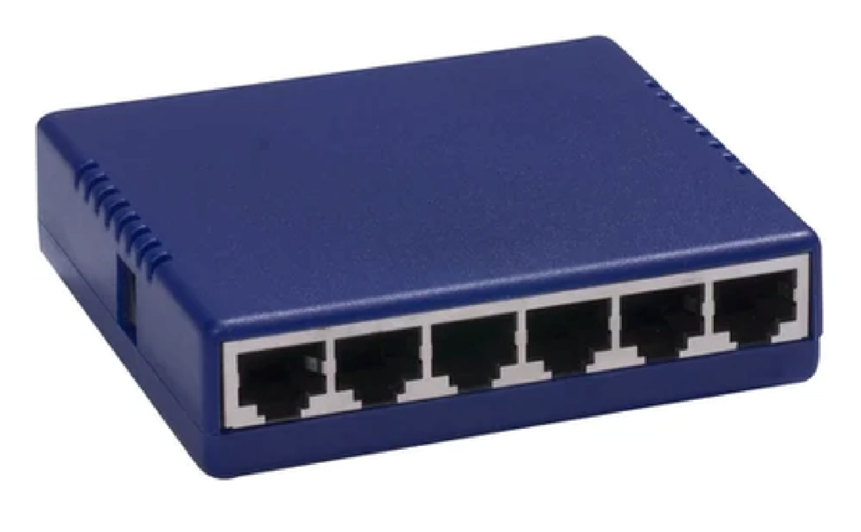
- Hub or Switch:

- Computer or Node:
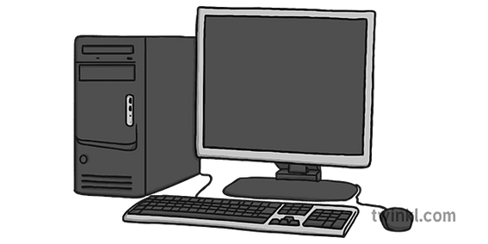

- Access Point
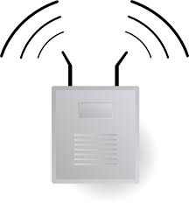

- Modem




